SRM Institute of Science and Technology

Mode of Exam

**OFFLINE**

**SET B**

College of Engineering and Technology

DEPARTMENT OF ECE

SRM Nagar, Kattankulathur – 603203, Chengalpattu District, Tamil Nadu

Academic Year: 2021-22 (ODD)

Test: **CLAT-2** Date: **31/05/22**

Course Code & Title: 18ECC202J / Linear Integrated Circuits Duration: 2 Periods

Year & Sem: II year / IV Sem Max. Marks: 50

Course Articulation Matrix:

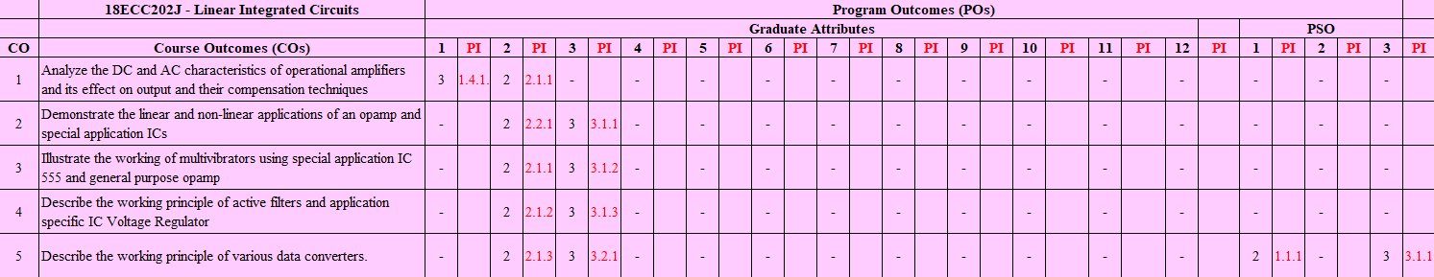

|  |  |  |  |  |  |  |
| --- | --- | --- | --- | --- | --- | --- |
| **Q. NO** | **Question** | Marks | BL | CO | PO | PI |
| 1. | A. Open Loop | **1** | **1** | **2** | **2** | **2.2.1** |
| 2. | B. Vγ/AoL | **1** | **2** | **2** | **3** | **2.2.1** |
| 3. | B. Decreases with the increase in frequency | **1** | **1** | **2** | **2** | **2.2.1** |
| 4. | B. -1000 | **1** | **2** | **2** | **3** | **2.2.1** |
| 5. | D. Voltage follower | **1** | **1** | **2** | **2** | **2.2.1** |
| 6. | B. | **1** | **1** | **3** | **3** | **2.1.1** |
| 7. | C. VCC | **1** | **2** | **3** | **3** | **2.1.1** |
| 8. | A. Lock in range | **1** | **1** | **3** | **3** | **2.1.1** |
| 9. | B. Vcc to 0.5Vcc | **1** | **1** | **3** | **2** | **2.1.1** |
| 10. | A. 50% | **1** | **3** | **3** | **2** | **2.1.1** |
| **Part – B**  **( 4 x 10 = 40 Marks)** | | | | | |  |
| **SECTION B1**  **Instructions: Answer ANY 2 Questions** | | | | | |  |
| 11. | Design an op-amp to differentiate an 100 Hz signal and draw the output waveform for a sine input of 1V peak to peak. | 10 | 3 | 2 | 3 | 3.1.1 |
| 12. |  | 10 | 3 | 2 | 2 | 2.2.1 |
| 13a) | V-I Convertor with grounded load | 4 | 2 | 2 | 2 | 2.2.1 |
| 13b) |  | 6 | 4 | 2 | 3 | 3.1.1 |
| **SECTION B2**  **Instructions: Answer ANY 2 Questions** | | | | | |  |
| 14. | Saw tooth wave form generator : | 10 | 3 | 3 | 2 | 2.1.1 |
| 15a) |  | 8 | 3 | 3 | 2 | 2.1.1 |
| 15b) | T = 1.1RC  Given T = 100ms, R = 100kΩ  C = T/1.1R = 0.9µF | 2 | 3 | 3 | 3 | 3.1.2 |
| 16a) |  | 4 | 4 | 3 | 2 | 2.1.1 |
| 16b) | Applications:    **Frequency Translation:** | 6 | 2 | 3 | 2 | 2.1.1 |

Course Outcome (CO) and Bloom’s level (BL) Coverage in Questions

**Approved by the Course Coordinator**